# How Home Networks work

 Typically home networks are private network with a internet connection  Network is managed by routers where

 DHCP

 Router (This is a device to forward traffic from one network to another)

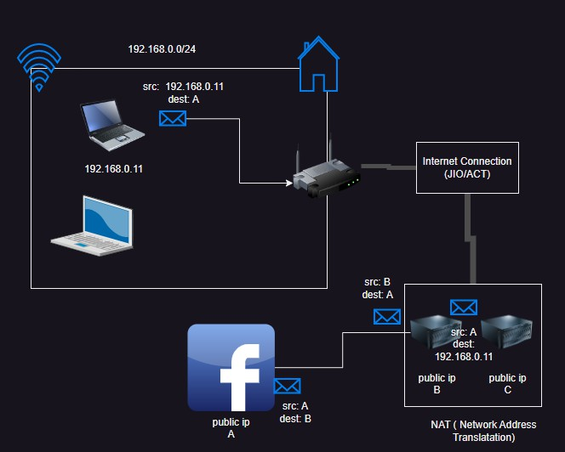 In a public network, a device will respond to another device when they can interact directly

 NAT (Network Address Translation) servers play a key role to provide access to the private networks to get internet access.

# AWS Networking Basics

 In AWS, we can create networks using vpc (Virtual private cloud).

 By default in every region, in your account you will have a default vpc.  VPC belongs to a region and subnet to an AZ

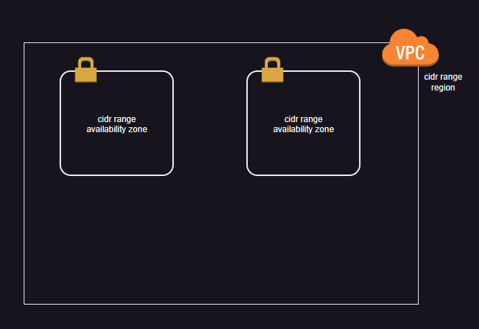We can create vpc and subnets

Every vpc will have a default route table (router) which enables all internal communication.

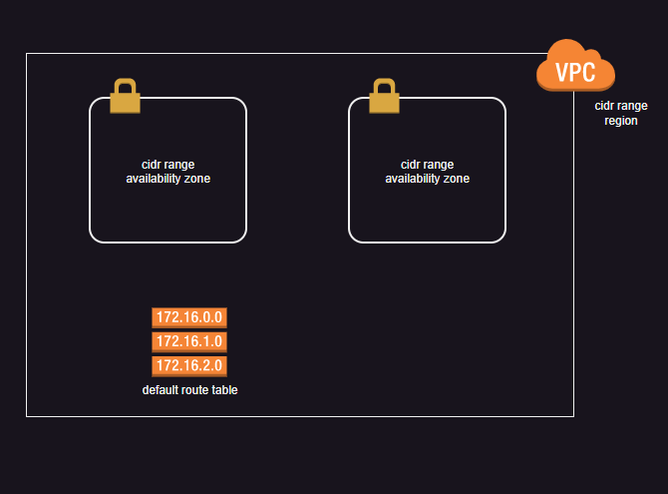

If you want to make your network accesible from outside, You need to have an internet-gateway

associated with your vpc (internet connection) and we need to associate a route between route table

and internet gateway

 Every subnet will be associated with

 route table with explicit connection

 default route table (without explicit connection)  Subnets in AWS can be private or public.

 public subnets are associate with route table which have route to internet gateway and private subnets have assocaiation with route tables which donot have route to internet gateway

 Private subnets can get internet access with the help of NAT Gateway created in a public subnet and modifying routetable

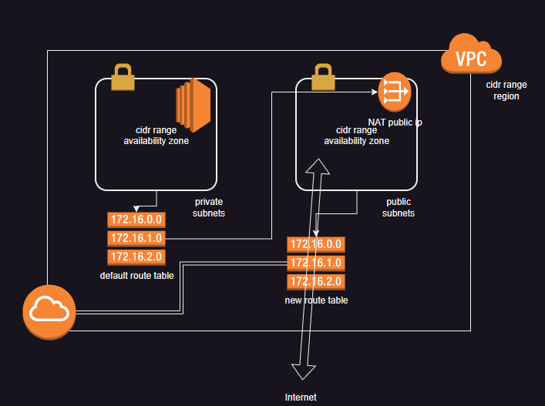 In AWS we have default vpc where all subnets are public.

# Azure networking basics

 In Azure we create networks with the help of virtual networks  In Azure network belongs to a region

 Azure Subnet also belong to a region

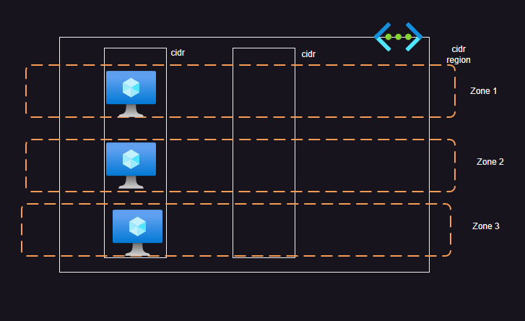While creating resources we can select the subnet and zone

Every Azure network has an internet connection established by default.

Azure gives a default routes (system defined routing), All the machines will get internet connection. Any machine can be given a public ip then it gets bidirectional internet.